User Guide 35 Applying for a standard digital certificate
Purpose of this Guide
The purpose of this guide is to provide information on the process in applying for a standard digital certificate.

Notes
- Once your organisation has a valid Certificate Manager digital certificate you may apply for subsequent standard digital certificates.
- Standard certificates are quicker, easier and cheaper to obtain than a Manager certificate. Both types of certificates can be used to digitally sign documents in SPEAR.
- You will need to know the ABN (Australian Business Number) used by your organisation to enrol with DigiCert.
- There are several passwords required. Record them securely and where possible, nominate the same password throughout the process.
- You will need to have access to your digital certificate store in your Internet Explorer web browser later in the download process. If you do not have the required security level to view your certificates, please contact your IT department before continuing with the application.
35.1 Commence Online Enrolment:
1. Navigate to the SPEAR Digital Certificate page on the DigiCert web site and read through the information.
https://gatekeeper.digicert.com/spear
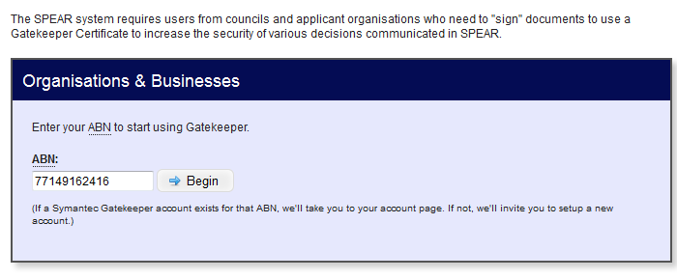
Enter ABN number for your organisation and click ‘Begin’.

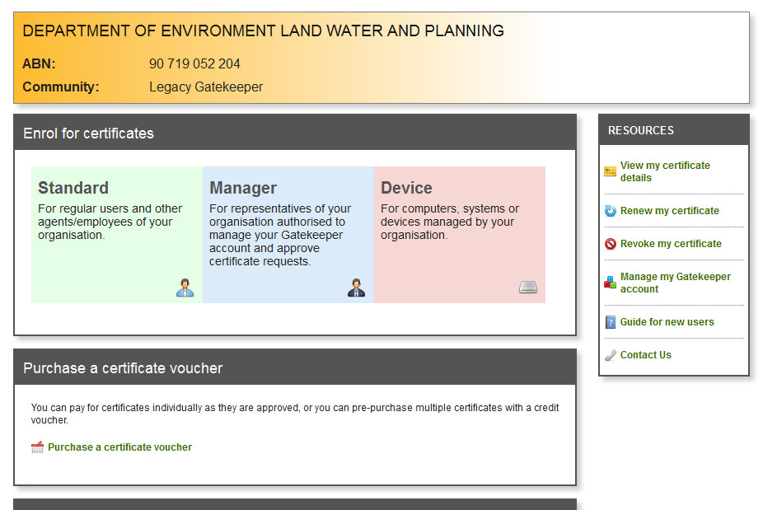

Select ‘Standard’.

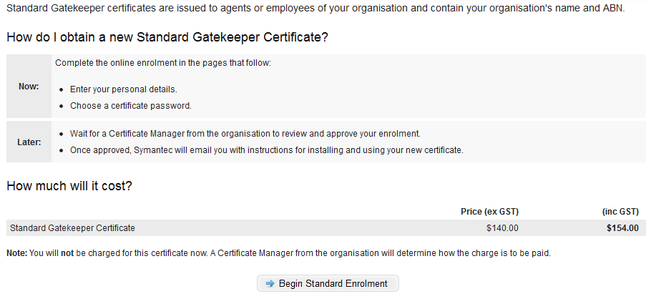
Review instructions and click ‘Begin Standard Enrolment’.

2. 'Enrolment Details'.
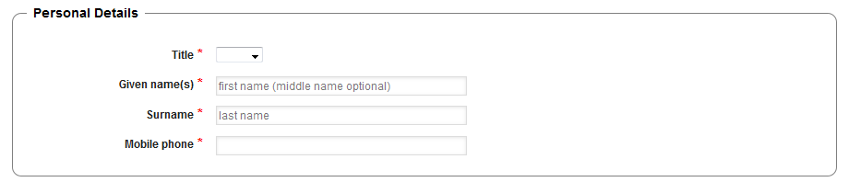
Enter details of your name in full.

A mobile phone number is required for the instalment process.

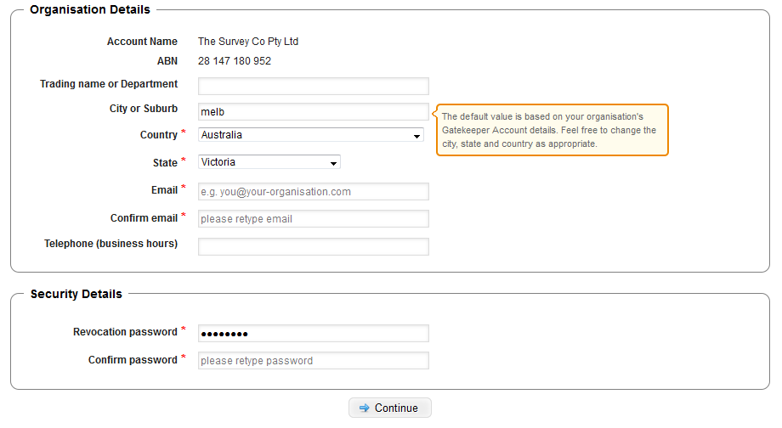
Review details of Trading name or Department.

Securely record this password.
It is required if revoking or renewing your certificate.

Enter a revocation password and confirm.

3. Confirmation screen
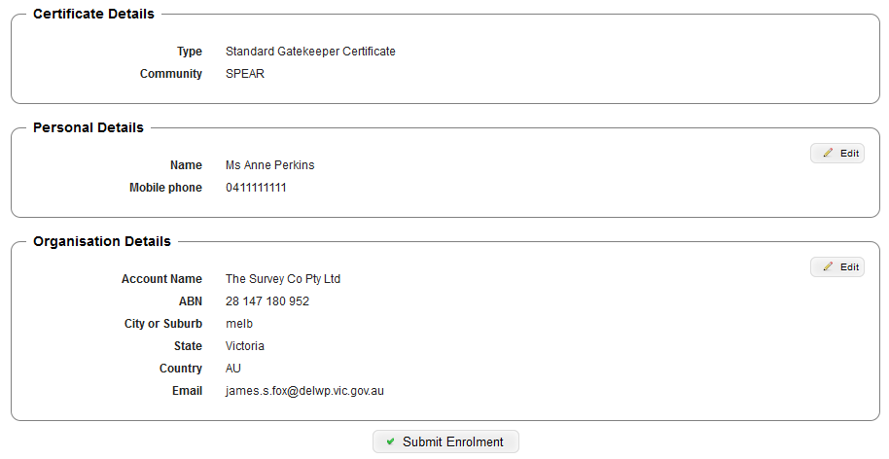

If all details are correct. Click ‘Submit Enrolment'

4. Application finished:
You should now have a page displayed, informing you have finished the application process. (Please refer to screen image on the following page.) Please read the instructions on this page carefully.
You will receive a confirmation email from DigiCert. You will need to forward this email onto your organisation's Certificate Manager for them to approve your application and pay for your certificates. You will receive a notification and instructions from DigiCert via email shortly after the certificates have been purchased and approved.
35.2 Next Steps:
Once you have received your certificates from DigiCert you will need to download and back them up. Further information can be found in User Guide 33 - Download and backing up your digital certificate.
Need more information?
Further information on this topic can be found by:
- Visiting the SPEAR website www.spear.land.vic.gov.au/SPEAR.
- Contacting the SPEAR Service Desk on 9194 0612 or email spear.info@delwp.vic.gov.au

